|  |
| --- |
|  |
|  |
| http://chamsolyoon.azurewebsites.net/ |
| Version #0.0  All work Copyright © 2016 by Team name here.  All rights reserved.  **Chamsol, Ilgu, Kevin** |
|  |
|  |
|  |



|  |
| --- |
| Nov 22st 2016 |

Table of Contents

1. Version History 3

2. Detailed Game Description 4

3. Controls 4

4. Interface Sketch 1 5

5. Interface Sketch 2 6

6. Game world 8

7. Characters 9

8. Scoring (total 5 lives) 10

# Version History

|  |  |  |  |
| --- | --- | --- | --- |
| Date | Version | Contributor | Comments |
| Nov 22 2016 | 0.0 | Chamsol Yoon | Finished Game Scenario |
|  |  |  |  |

# Detailed Game Description

1. Story background

Our fancy space shot game aims to provide players excellent experiences. Our main character is a brave explorer taking a space ship to find more minerals for earth, which is facing extreme shortage of energy. Unfortunately, there are many dangerous aerolites floating in the deep space.

Our brave pilot should avoid all these deadly stones and collect as many minerals for our earth.

1. Architecture

Our game has three levels.

Level 1: our ship could not fire missiles, only collects minerals for incoming upgrade. The aerolites seldom to appear. On average one aerolite per screen. After updating successfully, our game will move to level 2.

Level 2: our ship could fire missiles, not only collects minerals for incoming upgrade. The aerolites appear more. On average two aerolites per screen. The missiles can destroy the aerolites, which can

Increase the scores of ship.

Level 3: our ship could fire more missiles, The aerolites appear more. On average four aerolites per screen. The missiles can destroy the aerolites, which can increase the scores of ship.

1. Winning criteria

When the scores accumulate up 10000, the player wins the game. Otherwise, the player will lose.

# Controls

(add screenshot)

Direction controls:

The spaceship will follow the positions of mouse, but only the y position. X position will be

constrained in a certain line.

Missile controls:

When the ship updates successfully, players can left click the mouse to emit missles.

# Interface Sketch 1

* A scene flows sketch

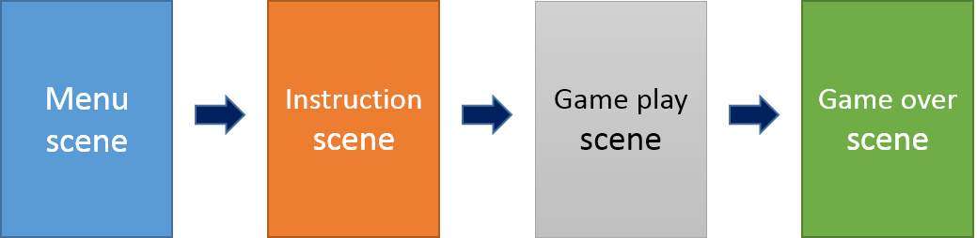

(include main menu)

# Interface Sketch 2

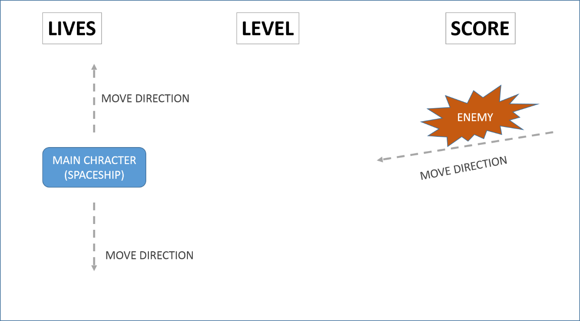

**Interface planning**

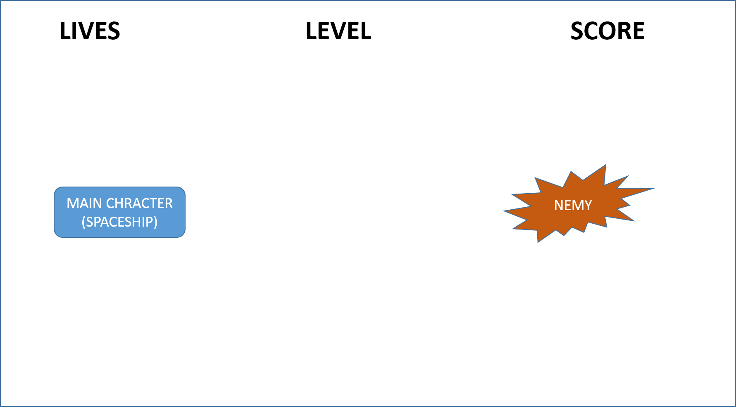

**Interface – Level 1**

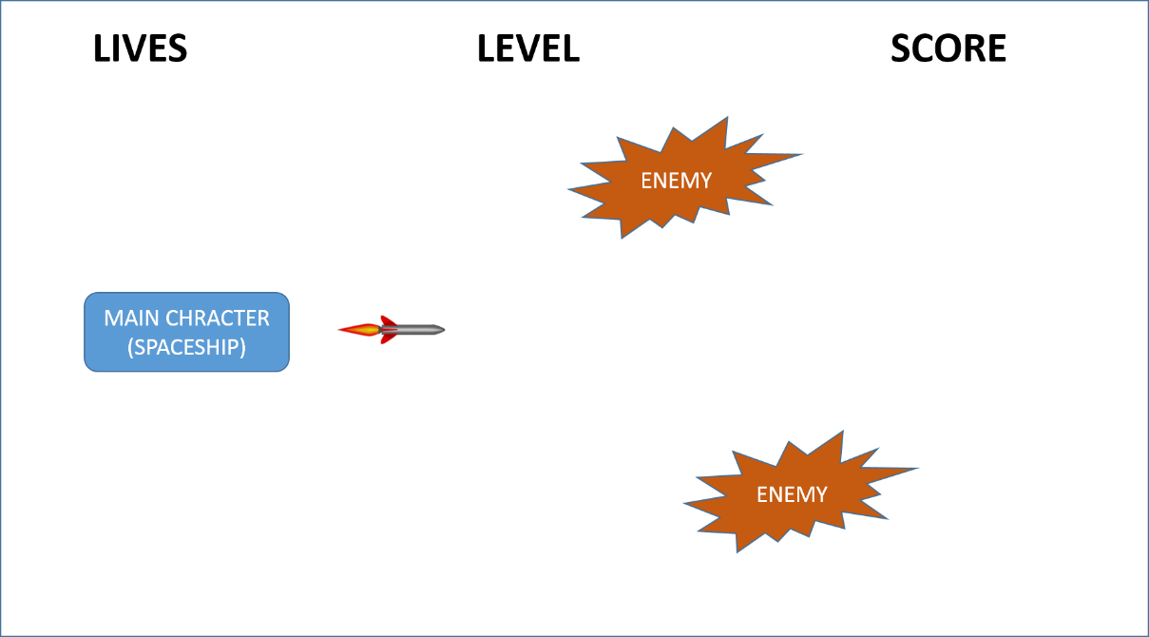

**Interface – Level 2**

**Able to fire a missile and a number of enemy*2**

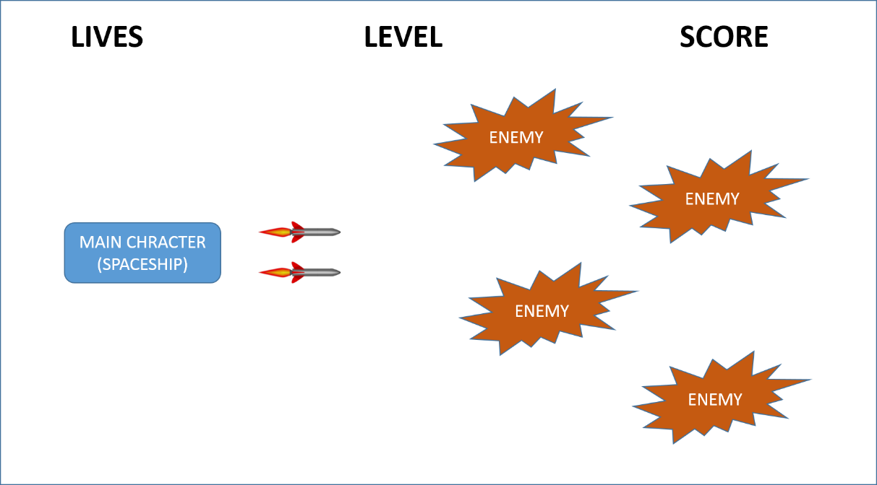

**Interface – Level 3**

**Able to fire two missiles and a number of enemy*2**

(missile upgrade)

# Game world

(scrollable background)

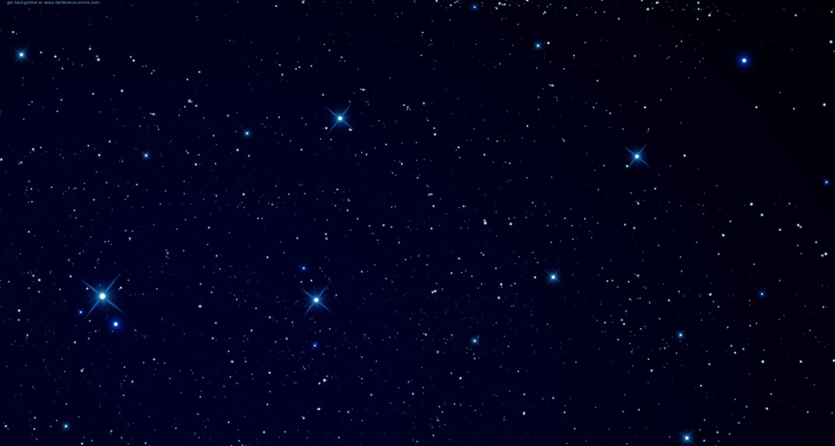

**Space – Level 1**

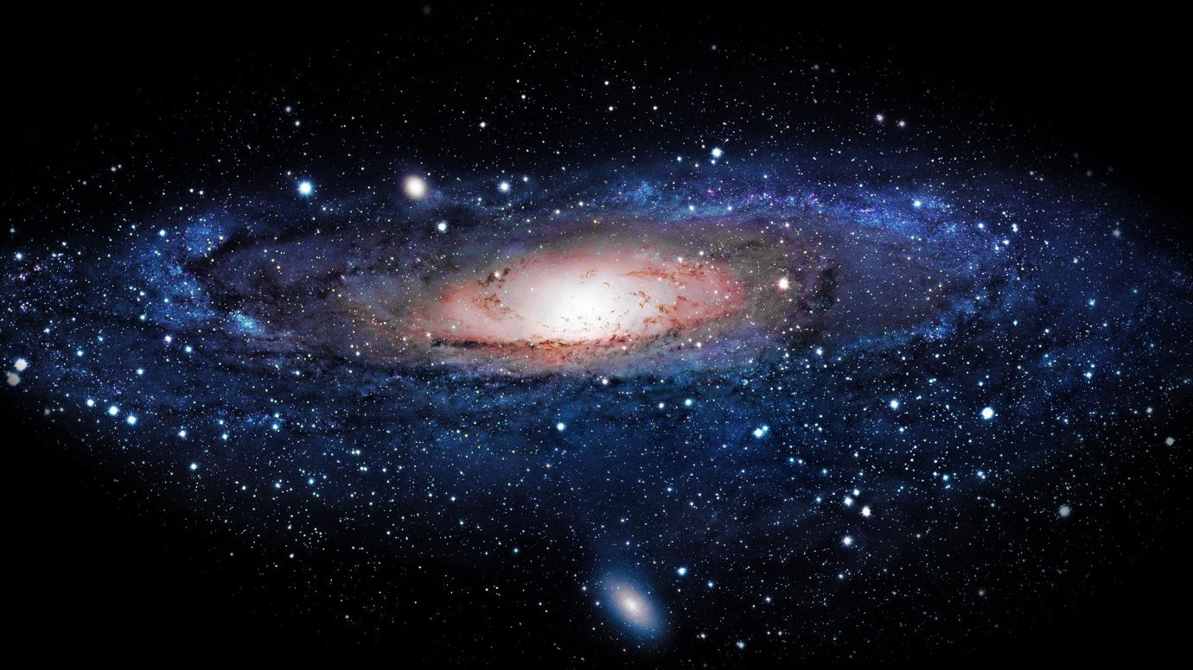

**Space – Level 2**

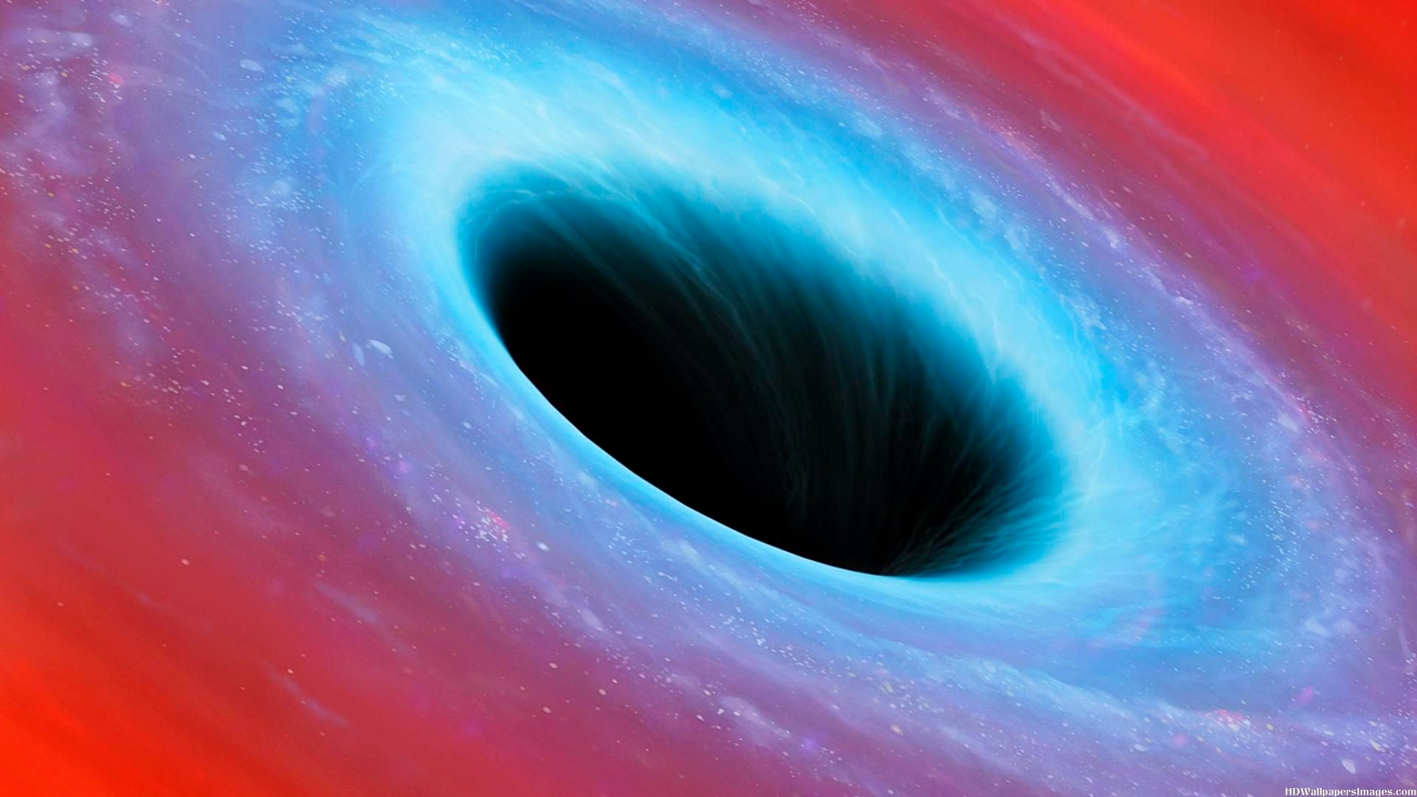

**Space – Level 3**

# Characters

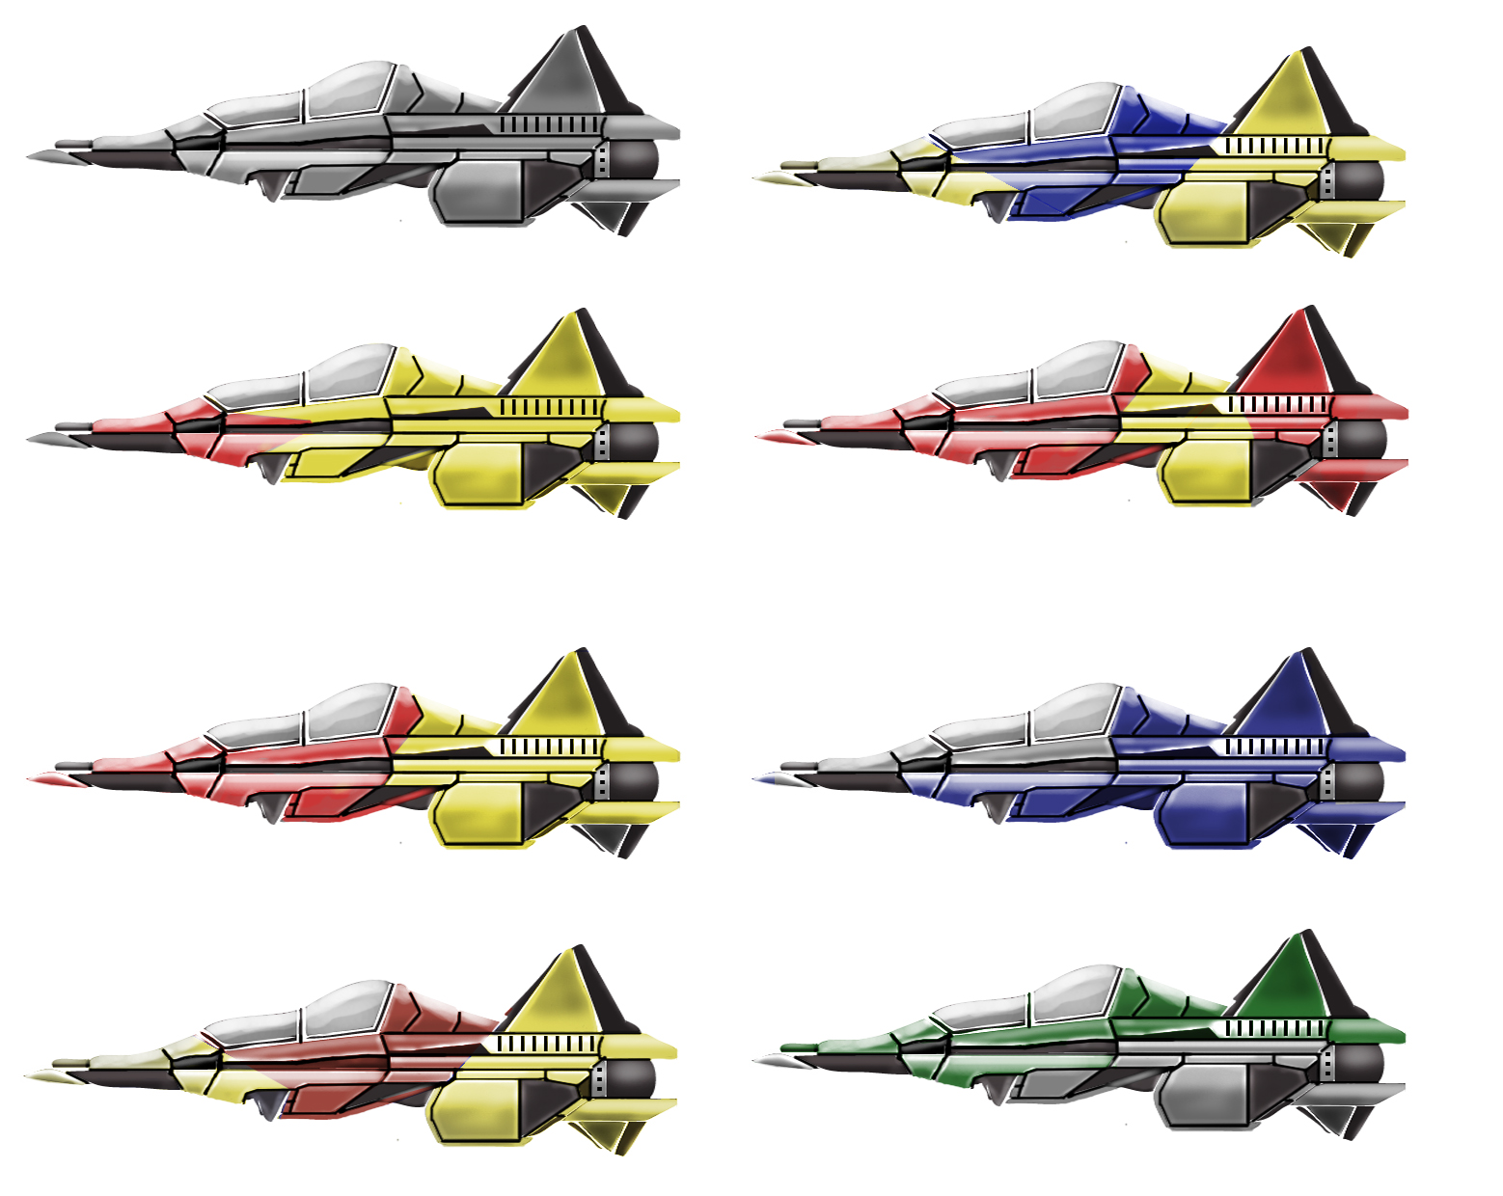

**Main character**

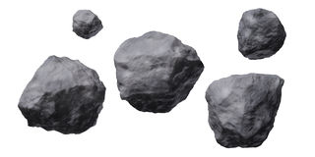

**Enemy**

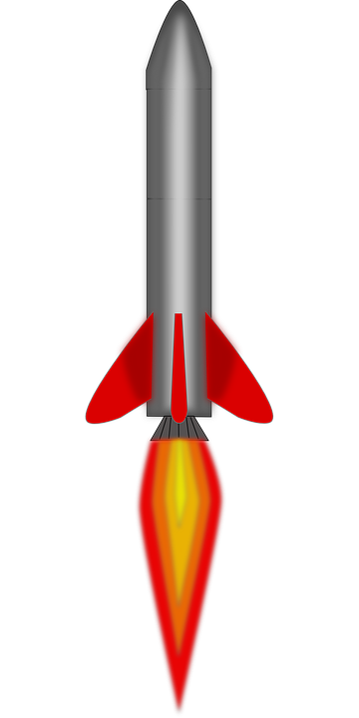

**Weapon**



**Bonus**

# Scoring (total 5 lives)

|  |  |  |
| --- | --- | --- |
| object | lives | score |
| Hit enemy | -1 |  |
| Get diamond |  | +100 |
| Destroy one aerolite |  | +200 |
| Update to level 2 need |  | +2000 |
| Update to level 3 need |  | +5000 |
| Win the game need |  | +10000 |

(reference ikaruga, r-type)